**Ideation Phase**

**Define the Problem Statements**

|  |  |
| --- | --- |
| Date | 30 October 2025 |
| Team ID | NM2025TMID06300 |
| Project Name | Laptop Request Catalog Item |
| Maximum Marks | 2 Marks |

**Customer Problem Statement Template:**

Create a problem statement to understand your customer's point of view. The Customer Problem Statement template helps you focus on what matters to create experiences people will love.

A well-articulated customer problem statement allows you and your team to find the ideal solution for the challenges your customers face. Throughout the process, you’ll also be able to empathize with your customers, which helps you better understand how they perceive your product or service.

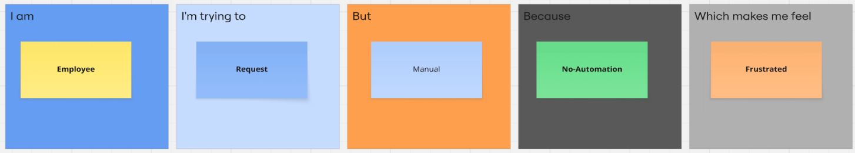

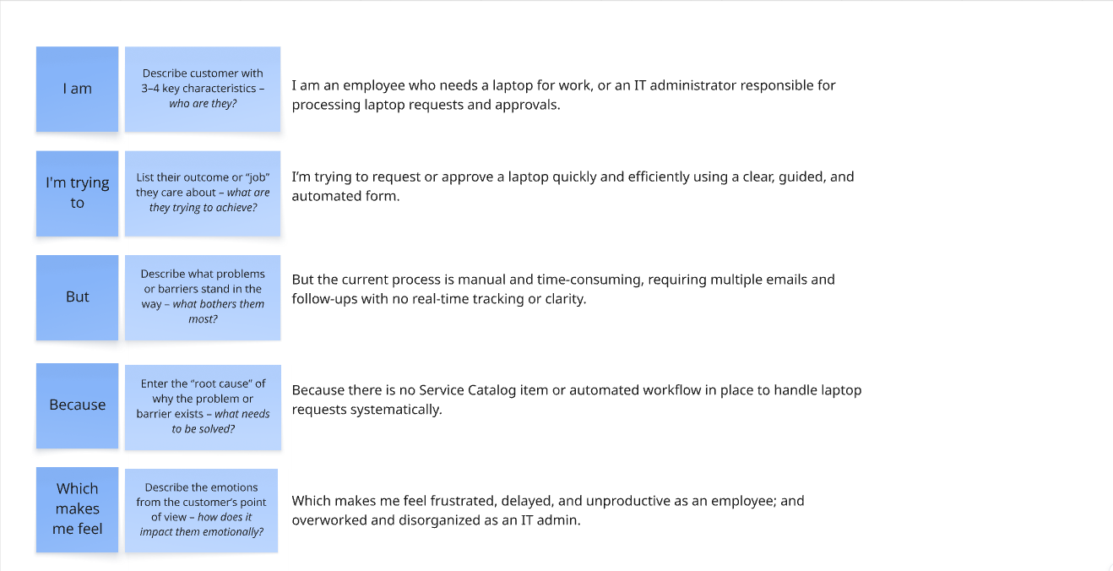

|  |  |  |  |  |  |
| --- | --- | --- | --- | --- | --- |
| **Problem Statement** | **I am (Customer)** | **I’m trying to** | **But** | **Because** | **Which makes me feel** |
| I am an employee who needs a laptop for remote work, but the request system often crashes and delays my approval. | I am an employee in the organization who needs a laptop for my daily work | request a laptop quickly and easily through the system | the current process is manual and time-consuming | there is no automated catalog form or workflow to guide me | frustrated, delayed, and unproductive |
| I am an IT administrator trying to process laptop requests, but incomplete details cause delays.. | I am an IT administrator responsible for managing laptop requests | track and process laptop requests efficiently | there is no centralized or dynamic system to manage approvals and records | all requests come through emails or inconsistent forms | overwhelmed, disorganized, and stressed about tracking errors |